# HTML Tutorial: Lists and Tables | Web Development Tutorials #7

#### **HTML Tutorial: Lists and Tables**

In this tutorial, we will work on the concepts of Lists and Tables in HTML. So, let us start by making a new file as tut.html and add the boilerplate to get the necessary HTML template. Give the title as **Tables and Lists in** <title> tag.

The lists are basically of two types-

An unordered HTML list:

* Item
* Item
* Item
* Item

An ordered HTML list:

1. First item
2. Second item
3. Third item
4. Fourth item

## **HTML List Tags**

|  |  |
| --- | --- |
| **Tag** | **Description** |
| [<ul>](https://www.w3schools.com/tags/tag_ul.asp) | Defines an unordered list |
| [<ol>](https://www.w3schools.com/tags/tag_ol.asp) | Defines an ordered list |
| [<li>](https://www.w3schools.com/tags/tag_li.asp) | Defines a list item |
| [<dl>](https://www.w3schools.com/tags/tag_dl.asp) | Defines a description list |
| [<dt>](https://www.w3schools.com/tags/tag_dt.asp) | Defines a term in a description list |
| [<dd>](https://www.w3schools.com/tags/tag_dd.asp) | Describes the term in a description list |

## **Unordered HTML List - Choose List Item Marker**

The CSS list-style-type property is used to define the style of the list item marker. It can have one of the following values:

|  |  |
| --- | --- |
| **Value** | **Description** |
| disc | Sets the list item marker to a bullet (default) |
| circle | Sets the list item marker to a circle |
| square | Sets the list item marker to a square |
| none | The list items will not be marked |

### **Example - Circle**

<ul style="list-style-type:circle;">  
  <li>Coffee</li>  
  <li>Tea</li>  
  <li>Milk</li>  
</ul>

### **Example - Square**

<ul style="list-style-type:square;">  
  <li>Coffee</li>  
  <li>Tea</li>  
  <li>Milk</li>  
</ul>

## **Ordered HTML List - The Type Attribute**

The type attribute of the <ol> tag, defines the type of the list item marker:

|  |  |
| --- | --- |
| **Type** | **Description** |
| type="1" | The list items will be numbered with numbers (default) |
| type="A" | The list items will be numbered with uppercase letters |
| type="a" | The list items will be numbered with lowercase letters |
| type="I" | The list items will be numbered with uppercase roman numbers |
| type="i" | The list items will be numbered with lowercase roman numbers |

### **Uppercase Letters:**

<ol type="A">  
  <li>Coffee</li>  
  <li>Tea</li>  
  <li>Milk</li>  
</ol>

**Tables:**

## **HTML Table Tags**

|  |  |
| --- | --- |
| **Tag** | **Description** |
| [<table>](https://www.w3schools.com/tags/tag_table.asp) | Defines a table |
| [<th>](https://www.w3schools.com/tags/tag_th.asp) | Defines a header cell in a table |
| [<tr>](https://www.w3schools.com/tags/tag_tr.asp) | Defines a row in a table |
| [<td>](https://www.w3schools.com/tags/tag_td.asp) | Defines a cell in a table |
| [<caption>](https://www.w3schools.com/tags/tag_caption.asp) | Defines a table caption |
| [<colgroup>](https://www.w3schools.com/tags/tag_colgroup.asp) | Specifies a group of one or more columns in a table for formatting |
| [<col>](https://www.w3schools.com/tags/tag_col.asp) | Specifies column properties for each column within a <colgroup> element |
| [<thead>](https://www.w3schools.com/tags/tag_thead.asp) | Groups the header content in a table |
| [<tbody>](https://www.w3schools.com/tags/tag_tbody.asp) | Groups the body content in a table |
| [<tfoot>](https://www.w3schools.com/tags/tag_tfoot.asp) | Groups the footer content in a table |

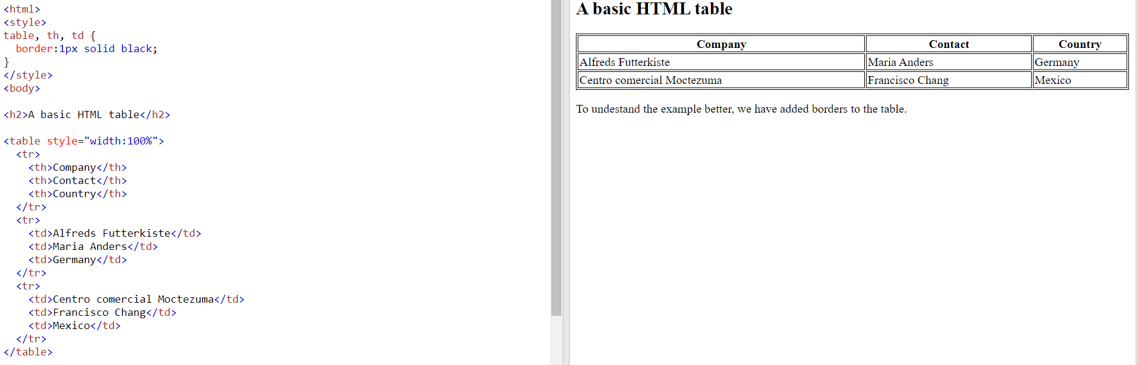

## **How To Add a Border**

When you add a border to a table, you also add borders around each table cell:

|  |  |  |
| --- | --- | --- |
|  |  |  |
|  |  |  |
|  |  |  |

To add a border, use the CSS border property on table, th, and td elements:

### **Example**

table, th, td {  
  border: 1px solid black;  
}

## **Collapsed Table Borders**

To avoid having double borders like in the example above, set the CSS border-collapse property to collapse.

This will make the borders collapse into a single border:

|  |  |  |
| --- | --- | --- |
|  |  |  |
|  |  |  |
|  |  |  |

### **Example**

table, th, td {  
  border: 1px solid black;  
  border-collapse: collapse;  
}

[Try it Yourself »](https://www.w3schools.com/html/tryit.asp?filename=tryhtml_table_collapse)

ADVERTISEMENT

## **Style Table Borders**

If you set a background color of each cell, and give the border a white color (the same as the document background), you get the impression of an invisible border:

|  |  |  |
| --- | --- | --- |
|  |  |  |
|  |  |  |
|  |  |  |

### **Example**

table, th, td {  
  border: 1px solid white;  
  border-collapse: collapse;  
}  
th, td {  
  background-color: #96D4D4;  
}

[Try it Yourself »](https://www.w3schools.com/html/tryit.asp?filename=tryhtml_table_border_style)

## **Round Table Borders**

With the border-radius property, the borders get rounded corners:

|  |  |  |
| --- | --- | --- |
|  |  |  |
|  |  |  |
|  |  |  |

### **Example**

table, th, td {  
  border: 1px solid black;  
  border-radius: 10px;  
}

[Try it Yourself »](https://www.w3schools.com/html/tryit.asp?filename=tryhtml_table_border_round1)

Skip the border around the table by leaving out table from the css selector:

|  |  |  |
| --- | --- | --- |
|  |  |  |
|  |  |  |
|  |  |  |

### **Example**

th, td {  
  border: 1px solid black;  
  border-radius: 10px;  
}

[Try it Yourself »](https://www.w3schools.com/html/tryit.asp?filename=tryhtml_table_border_round2)

## **Dotted Table Borders**

With the border-style property, you can set the appereance of the border.

|  |  |  |
| --- | --- | --- |
|  |  |  |
|  |  |  |
|  |  |  |

The following values are allowed:

* dotted
* dashed
* solid
* double
* groove
* ridge
* inset
* outset
* none
* hidden

### **Example**

 th, td {  
  border-style: dotted;  
}

[Try it Yourself »](https://www.w3schools.com/html/tryit.asp?filename=tryhtml_table_border_dotted)

## **Border Color**

With the border-color property, you can set the color of the border.

|  |  |  |
| --- | --- | --- |
|  |  |  |
|  |  |  |
|  |  |  |

### **Example**

 th, td {  
  border-color: #96D4D4;  
}

# HTML Table Sizes

Use the style attribute with the width or height properties to specify the size of a table, row or column.

<table style="width:100%">

## **HTML Table Column Width**

|  |  |  |
| --- | --- | --- |
|  |  |  |
|  |  |  |
|  |  |  |

To set the size of a specific column, add the style attribute on a <th> or <td> element:

<table style="width:100%">  
  <tr>  
    <th style="width:70%">Firstname</th>  
    <th>Lastname</th>  
    <th>Age</th>  
  </tr>

## **HTML Table Row Height**

|  |  |  |
| --- | --- | --- |
|  |  |  |
|  |  |  |
|  |  |  |

To set the height of a specific row, add the style attribute on a table row element:

<tr style="height:200px">  
    <td>Jill</td>  
    <td>Smith</td>  
    <td>50</td>  
  </tr>

## **Align Table Headers**

By default, table headers are bold and centered:

|  |  |  |
| --- | --- | --- |
| **Firstname** | **Lastname** | **Age** |
| Jill | Smith | 50 |
| Eve | Jackson | 94 |

To left-align the table headers, use the CSS text-align property:

### **Example**

th {  
  text-align: left;  
}

# HTML Table Padding & Spacing

[❮ Previous](https://www.w3schools.com/html/html_table_headers.asp)[Next ❯](https://www.w3schools.com/html/html_table_colspan_rowspan.asp)

HTML tables can adjust the padding inside the cells, and also the space between the cells.

|  |  |  |
| --- | --- | --- |
| With Padding | | |
| hello | hello | hello |
| hello | hello | hello |
| hello | hello | hello |

|  |  |  |
| --- | --- | --- |
| With Spacing | | |
| hello | hello | hello |
| hello | hello | hello |
| hello | hello | hello |

## **HTML Table - Cell Padding**

Cell padding is the space between the cell edges and the cell content.

By default the padding is set to 0.

To add padding on table cells, use the CSS padding property:

### **Example**

th, td {  
  padding: 15px;  
}

[Try it Yourself »](https://www.w3schools.com/html/tryit.asp?filename=tryhtml_table_cellpadding)

To add padding only above the content, use the padding-top property.

And the others sides with the padding-bottom, padding-left, and padding-right properties:

### **Example**

th, td {  
  padding-top: 10px;  
  padding-bottom: 20px;  
  padding-left: 30px;  
  padding-right: 40px;  
}

[Try it Yourself »](https://www.w3schools.com/html/tryit.asp?filename=tryhtml_table_cellpadding2)

## **HTML Table - Cell Spacing**

Cell spacing is the space between each cell.

By default the space is set to 2 pixels.

To change the space between table cells, use the CSS border-spacing property on the table element:

### **Example**

table {  
  border-spacing: 30px;  
}

* **Ordered lists (ol)**

<ol>

<li>This is the first item of my unordered list</li>

</ol>

Copy

* **Unordered lists (ul)**

<ul>

<li>This is the first item if my unordered list</li>

</ul>

Copy

The difference between an ordered and an unordered list is that the ordered list displays the list in this format **-**

**1.**

**2.**

**3.**

**….**

On the other hand, the unordered lists display the list in the following format-

* **.**
* **.**
* **.**

**….**



Both the lists have more than one attribute which we can write using the type command. For example, if we write:

<ol type= “I”>

Copy

 Then we will get the lists as I, II, III, and so on. In the same format, we can also get the lists as A, B, C, and so on.

This applies on unordered lists also. If we write

<ul type= “square”>

Copy

Then we will get a bulleted square instead of a circle. There are various other references available from which you can see all the attributes. There is no need to learn all these things. You will get perfect by practising.



HTML also allows the nesting of lists. It simply means we can add a list into another list.

<ul type="circle">

<li>This is first item of my unordered list</li>

<li>This is second item of my unordered list</li>

<ul>

<li>Another one</li>

<li>Another two</li>

<li>Another three</li>

</ul>

Copy

Let us now discuss the **Tables**in HTML. A table is just a combination of rows and columns on a webpage. The structure of the table looks like-

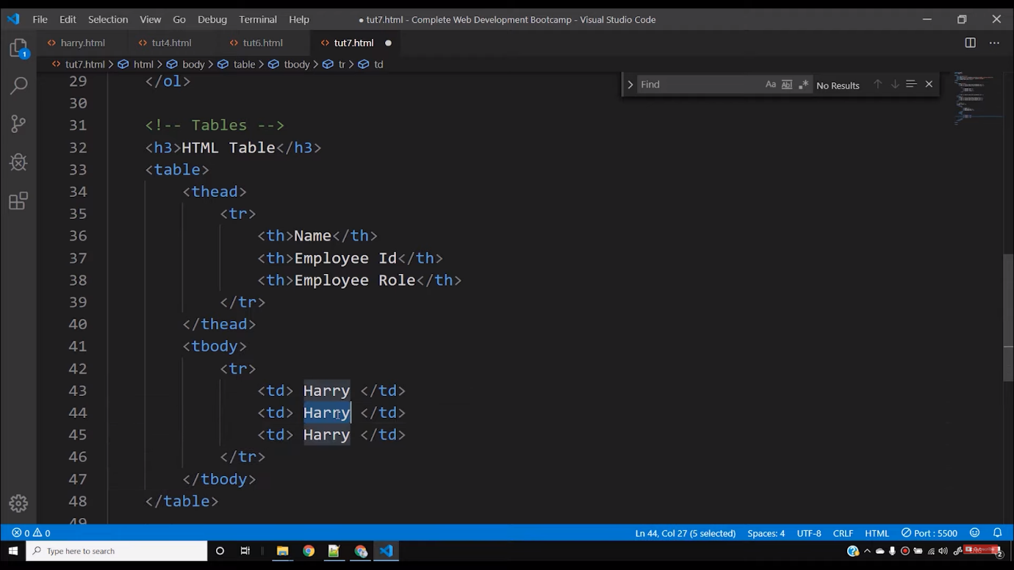

The main part is the table tag, and it consists of two parts: the table head and table body. The <thead> consists of the main head of the table and <tbody> consists of the body of the table.

<tr> is used to justify that it is the part of a row. Inside the <tr> tag, we give the headings of a row under the <th> tag. The final structure of a table looks like-

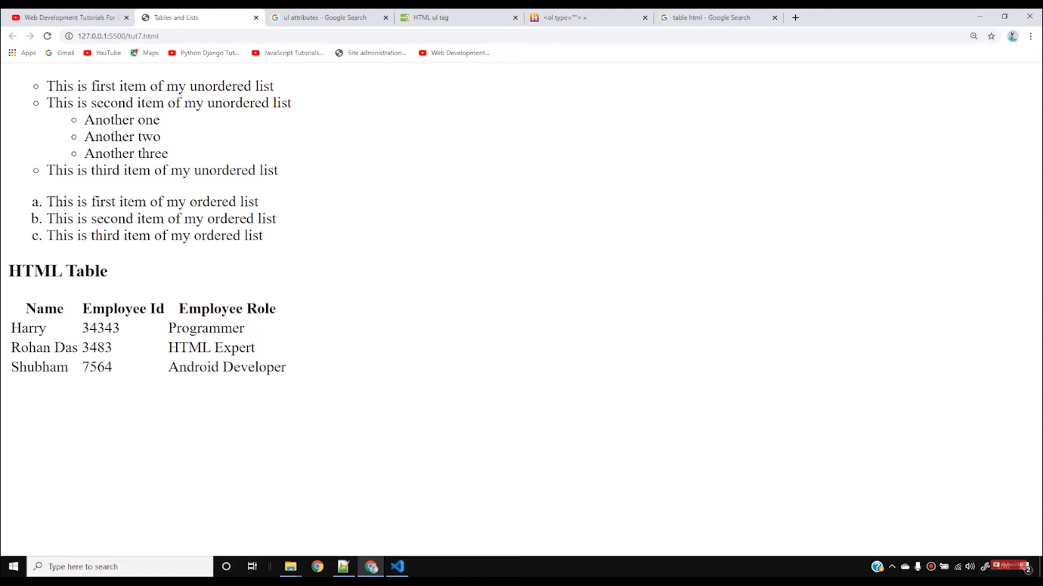

In a table, there are mostly two things to remember, the head and the body of a table. To add more rows to the table, we can simply add a <tr> tag and add any number of rows in a table.

I believe you have understood clearly what the lists and tables are. Tables and lists are two primary components of a website that helps in making it more attractive. There will be more tutorials coming to assist you in developing your site. So be patient and keep practising the things taught till now.

#### Code as described/written in the video

<!DOCTYPE html>

<html lang="en">

<head>

<meta charset="UTF-8">

<meta name="viewport" content="width=device-width, initial-scale=1.0">

<meta http-equiv="X-UA-Compatible" content="ie=edge">

<title>Tables and Lists</title>

</head>

<body>

<ul type="circle">

<li>This is first item of my unordered list</li>

<li>This is second item of my unordered list</li>

<ul>

<li>Another one</li>

<li>Another two</li>

<li>Another three</li>

</ul>

<li>This is third item of my unordered list</li>

</ul>

<ol type="a">

<li>This is first item of my ordered list</li>

<li>This is second item of my ordered list</li>

<li>This is third item of my ordered list</li>

</ol>

<!-- Tables -->

<h3>HTML Table</h3>

<table>

<thead>

<tr>

<th>Name</th>

<th>Employee Id</th>

<th>Employee Role</th>

</tr>

</thead>

<tbody>

<tr>

<td> Harry </td>

<td> 34343 </td>

<td> Programmer </td>

</tr>

<tr>

<td> Rohan Das</td>

<td> 3483 </td>

<td> HTML Expert </td>

</tr>

<tr>

<td> Shubham </td>

<td> 7564 </td>

<td> Android Developer </td>

</tr>

</tbody>

</table>

</body>

</html>